How to Interpret Biblical Literary Types

Singapore Bible College

Rick Griffith, ThM, PhD

First Edition
© January 2013

1st printing (70 sets; Jan 13)



Table of Contents

I. Introduction 3
II. Introduction: Interpreting the Literary Styles in the Bible 7
III. Basics for Interpreting All of Scripture 7
IV. Interpreting the Pentateuch’s Legal Literature 8
V. Interpreting the Historical Books (Narrative or Story) 11
VI. Interpreting the Wisdom & Poetic Books 13
VII. Interpreting the Prophets 16
VIII. Interpreting the Gospels & Acts 21
IX. Interpreting the Epistles 23
X. Interpreting Revelation 25

Introduction

Syllabus

Description
This study provides an overview of Scripture interpretation, followed by tips in understanding the various genre (literary types) throughout the Bible: Pentateuch, Historical Books, Poetic & Wisdom Literature, Prophets, Gospels, Epistles, and the book of Revelation.

Objectives

By the end of the study the student should be able to …

Articulate the basic rules of Bible interpretation.

Apply these principles to the different literature found in different sections of Scripture.

Requirements

Reading is not required in advance, but I hope you will read the sections we cannot cover after the seminar. I have given you more than we can cover in three hours.

Quizzes will come at various times in the seminar, but they are low-stress!

Bibliography (in addition to those on “How to Study & Teach the Bible” volume)

Fee, Gordon D. and Douglas Stuart. 2d ed. How to Read the Bible for All Its Worth. Grand Rapids: Zondervan, 1981, 1993.

Köstenberger, Andreas J. and Richard D. Patterson. Invitation to Biblical Interpretation: Exploring the Hermeneutical Triad of History, Literature, and Theology (Kregel, 2012). 900+ pp.

Other Matters

Contacting Me: You can contact me at SBC by box L19 or by phone (6559-1513). Also, my home is at Block 2-302 on the SBC campus, mobile is 9113-7090, and home phone number is 6762-2011 (email griffith@sbc.edu.sg). My office hours when I can talk are from 11:00-1:00 on Thursday and Friday and afternoons on Tuesday, Thursday, and Friday. Let’s have lunch too!

Copying Class Notes: Allowed when you give credit where credit is due (unless it makes you rich). You may also copy all course PPT and translate them into other languages. Digital copies in both pdf and Microsoft Word can be downloaded for free at www.biblestudydownloads.com.

Author’s Biographical Data



Rick and Susan Griffith
Kurt (26), Stephen (23) & John (20)

Background

“Never say ‘never.’” Rick and Susan Griffith both learned this age-old tip the hard way.

Rick recalls sitting in his elementary school classes thinking, “If there’s one thing I’ll never become it’s a teacher. Imagine saying the same stuff over and over, year after year!”

Yet after trusting Christ in junior high and acquiring a taste for teaching the Word of God, Rick’s attitude began to change. After his business degree at California State University, Hayward, and Master of Theology degree (Pastoral Ministries) and the Doctor of Philosophy degree (Bible Exposition) from Dallas Theological Seminary in Texas, Dr. Griffith soon found himself on the other end of the classroom—and loving it!

Susan, from Yucaipa, California, also learned not to say “never.” As she earned her Bachelor of Arts degree in piano at Biola University, several friends married and worked to put their husbands through three more years of seminary training. “I’ll never do that!” she exclaimed. Soon afterwards she invested three years (1981-1983) singing together with her future husband in the Crossroads, Campus Crusade's traveling music team in Asia. This nine member Philippines-based group shared Christ in the Philippines, China, Hong Kong, Korea, Japan, Macau, Thailand, Malaysia, Indonesia, and Singapore.

In December 1983 Susan’s “never” became a reality. She and Rick were married and like Jacob and Rachel of old, Susan also worked for her mate. During these seven seminary years Rick served as a pastor, corporate chaplain, and International Students church consultant. Susan taught women's Bible studies and often ministered by singing. Their primary church in Texas is Christ Chapel Bible Church in Fort Worth.

The Griffith family now includes three sons: Kurt (26 yrs.), Stephen (23 yrs.), and John (20 yrs.). During home assignment they minister mainly from the First Baptist Church of Yucaipa, California.

Ministry

However, since 1991 the Griffiths’ home has been Singapore where Rick serves as NT Department Coordinator with 30 other full-time faculty at Singapore Bible College. SBC has about 500 full-time students from 23 countries and 25 denominations, as well as many professionals in the certificate-level Centre for Continuing Theological Education (CCTE). During his first term he taught a variety of courses: Old Testament Survey, New Testament Survey, New Testament Backgrounds, Eschatology (the study of future things), Evangelism, Pastoral Epistles, Psalms, Homiletics (preaching), Hebrew Exegesis, and four Old Testament exposition courses. For many years he also taught Pentateuch, Gospels, Eschatology (theology of the future), Ecclesiology (theology of the church), and Pneumatology (theology of the Holy Spirit). Now he teaches mostly Bible Exposition classes, including Homiletics, World of the OT & NT, and NT Survey. He has also written the Advanced Studies in the Old and New Testament courses available for free at the Internet Biblical Seminary (www.internetseminary.org).

Dr. Griffith loves the variety and strategic nature of his teaching. He invests his life into Anglicans from Sri Lanka, Lutherans from Singapore, Presbyterians from Korea, Conservative Baptists from the Philippines, and missionaries from Campus Crusade, OMF, and Operation Mobilisation—sometimes all in one class! A survey of one of his courses revealed that 17 of the 20 students were training for ministry outside of Singapore. Nearly all SBC graduates enter pastoral or missionary ministries due to Asia’s shortage of trained leaders.

Ministry opportunities abound. Rick and Susan have conducted premarital counseling for students and their home has an open door to students and guests traveling through Singapore. They have sung in evangelistic thrusts and in 1992 also participated in founding International Community School, an expatriate Christian primary and secondary school in Singapore. The Griffiths are missionaries with WorldVenture (formerly CBInternational) and Rick serves as the Singapore field leader.

Dr Griffith also enjoys several other partnerships. He also serves as Singapore Director for BEE (Biblical Education by Extension); Asia Director & Translation Coordinator for "The Bible... Basically International" Seminars; Web Author & Editor, Internet Biblical Seminary; and itinerate professor at Lanka Bible College (Sri Lanka), Myanmar Evangelical Graduate School of Theology, Union Bible Training Center (Mongolia), Jordan Evangelical Theological Seminary, and BEE training in three restricted access countries.

In 2006 the Griffiths also helped begin Crossroads International Church, Singapore. Here “Dr. Rick” is “Pastor Rick” in his role as pastor-teacher and elder. The church meets Sunday afternoons at the Metropolitan YMCA at 60 Stevens Road from 4:00-5:30 PM. See cicfamily.com for details.

In 2009 Dr. Griffith developed a new website at www.biblestudydownloads.com where all ten of his courses are available for free download. This includes 5000 pages of his course notes in Word and pdf formats, more than 300 PowerPoint presentations in English, and hundreds of translations of these by his students into 36 languages. Current languages include Arabic, Bangla, Bengali, Burmese, Chin, Chinese, Dutch, French, Hindi, Indonesian, Japanese, Kachin, Khmer, Kiswahili, Korean, Lotha, Malay, Malayalam, Mao, Mizo, Mongolian, Nepali, Nias, Paite, Russian, Spanish, Sumi, Tagalog, Tamil, Tangkhul, Tenyidie, Thai, Vaiphei, Vietnamese, and Visayas.

Field

Singapore Bible College is strategically located at the “ministry hub” of Southeast Asia, the Republic of Singapore. A small island of only 14 by 26 miles, Singapore is a city-nation located on the tip of the Malayan Peninsula in Southeast Asia. The population of this multi-cultural society is 75 percent Chinese, 15 percent Malay and 8 percent Indian. Other groups include Filipinos, Thais, Japanese, Americans, and Europeans. This beautiful island nation, with dynamic growth in churches and missionary force, has been called the “Antioch of Asia.” The Singaporean cross-cultural missionary force is increasingly contributing to God’s work in overseas ministries.

Passion

Rick’s passion is for God’s leaders to preach and live the Word of God. The servant of God’s role is clearly given in the following verses:

- Teaching obedience to what Christ taught is a key part of our commission to make disciples (Matt. 28:20)
- The priority of the apostles was teaching and prayer (Acts 6:1-16)
- Paul’s legacy to Timothy focused on exposition: “Preach the Word” (2 Tim. 4:2-3)

However, recent trends include the following:

- Church people are biblically illiterate—Amos lamented in his day of prosperity that there existed a “famine for hearing the words of the Lord” (Amos 8:11)
- Pastors are doing too many things
- Preachers give empty and simplistic sermons
- Trying to be “relevant,” pastors preach what people want to hear—not what they need

Introduction: Interpreting the Literary Styles in the Bible

When reading English, we instinctively recognize certain literary types and how to interpret them. If a story begins, “Once upon a time…” we prepare ourselves for a fanciful world where animals talk, people fly, and dreams always come true. However, if the paper reads, “To whom it may concern…” we are ready for a stiff, stuffy style of facts about someone.

One of the reasons the Bible is the most loved, most read, most translated, most memorized, most distributed Book in the world is because of its amazing literary variety. In the pages of Scripture we find stories, poetry, prophecy, parables, and many other genres (literary types). Just as we realize to differ how to interpret the “once upon a time…” and the “to whom it may concern…” so we must do the same with Scripture.

This short study will begin with general rules of interpreting all Scripture. Then we will see how to use special skills to properly interpret various genres in the Bible.

Basics for Interpreting All of Scripture

Ask the Author: Always pray for wisdom before you begin to read God’s Word.

Start from the Top: Get the overview before you delve into details. Bible survey is a must! These sources can get you started:

“The Bible…Basically” goes through the Bible in a simple manner 6 times in a 9-hour seminar. It has almost 1000 PPT slides, an 80-page student workbook, and a 400-page teacher guide to know what to say for each slide. You can download the entire seminar on my www.biblestudydownloads.com website. It is being translated into 35 other languages and the “work in process” is on this site. Languages completed include Bahasa Indonesia, Chinese, Korean, Malay, and Mongolian.

My course notes for “Old Testament Survey” (2 vols.) and “New Testament Survey” (2 vols.) are much more detailed (over 2000 pages). However, they still give overviews of each book of Scripture as well as how the various books relate to each other. Printed copies can be purchased at the Singapore Bible College Book Centre or digital pdfs downloaded for free at www.biblestudydownloads.com.

Use a Logical Sequence: Follow these three steps in this order: observation, interpretation, and application.

Observation asks, “What do I see?”

Interpretation asks, “What does it mean?”

Application asks, “What does it mean to me?”

Be Literal: Take the normal sense until it doesn’t make sense. Use the normal, grammatical, historical method without spiritualizing the text.

Interpreting the Pentateuch’s Legal Literature

This quick quiz about the Law (first Five Books of Moses) will get you thinking…

T or F Christians should keep parts of the OT law which are not repeated in the NT.

T or F There are actually two laws: the moral (Ten Commandments) and ceremonial/civil.

T or F The Sabbath should still be obeyed by Christians.

T or F Believers today are obligated to keep all of the Ten Commandments.

T or F Tithing should be practiced by all followers of Christ.

T or F Christians today are prohibited from eating blood (e.g., yong tau foo, blood pudding, pig or duck blood at Chinese New Year).

T or F Believers must not charge other Christians interest based upon the Law (Deut. 23:19; Exod. 22:25; Lev. 25:36-37; Ezek. 18:8, 13, 17; 22:12; Prov. 15:5; 28:8).

Defining the Meaning of Law (adapted from Fee/Stuart, 135-36)

Sometimes “Law” refers to the Pentateuch as a single book (e.g., Josh. 1:8).

Sometimes Christians refer to the “Law” as the five books of the Pentateuch, even though Genesis has no legal codes.

NT usage of the term “Law” sometimes refers to the Pentateuch and sometimes the entire OT (e.g., Luke 16:17).

Oftentimes “Law” refers to only the legal formation from Exodus 20–Deuteronomy 33. (It always refers to at least this portion of Scripture.)

The Christian’s Relationship to the Law

The OT law is a covenant between Israel and God–not between the church and God. The church and Israel must be kept distinct.

Our loyalty to God is shown in different ways than was Israel’s. In other words, God expected Israel to be loyal and He expects the same of us, but Israel showed loyalty by observing the sacrificial system while we show loyalty by our obeying NT commands. (However, faith is what pleased God then and now–Heb. 11:6.)

Most OT stipulations are not repeated in the NT–especially the civil (penalties for crimes) and ritual (worship, especially sacrificial regulations) laws. Therefore, most of the OT does not directly apply to believers.

Some OT stipulations are repeated in the NT–including nine of the Ten Commandments, the exception being the Sabbath.

All of the OT law is still the Word of God for us even though it is not still the command of God for us. As such it is still useful for teaching and preaching, though applications must be made based upon the principles under girding the laws.

Only that which the NT explicitly renews from the OT law can be considered part of the NT “law of Christ” (Gal. 6:2). [Note: Fee/Stuart put all of the Ten Commandments in this category, which makes modern believers guilty of Sabbath breaking. I disagree that the Sabbath is binding in the present age. I worship corporately on Sunday, not Saturday!]

The Purposes of the Law

Paul’s letter to the Galatians teaches sanctification not by the Law but by faith in Christ alone. This finds support in that Abraham was justified by faith centuries before the Law even came (Gal. 3:17). After that, the Law and the Promise (Gen. 12:1-3) co-existed for years, so there is no basic conflict between the Law and the Promise. This led Paul to ask, “What, then, was the purpose of the law?” (Gal. 3:19). Actually, there were at least ten purposes for the Law:

It revealed or exposed the sinfulness of man (Gal. 3:19).

It revealed the holiness of God (1 Pet. 1:15).

It revealed the standard of holiness for people in fellowship with God (Ps. 24:3-5).

It supervised the physical, mental, and spiritual development of the redeemed Israelite until he could come to maturity in Christ (Gal. 3:24).

It unified the people to establish the nation in voluntary submission to God’s decrees (Exod. 19:5-8; Deut. 5:27-28).

It separated Israel among the nations as a kingdom of priests to mediate God’s truth to these nations (Exod. 31:13).

It provided forgiveness of sins for individual Israelites to restore their fellowship with God, even though they already functioned as a redeemed people (Lev. 1–7).

It made provision for Israel to worship God as a redeemed people (Lev. 23).

It tested if one was in the kingdom or the theocracy over which God ruled (Deut. 28). Faith led to obedience and blessing; lack of faith lead to disobedience and judgment.

It revealed Jesus Christ (typology in the sacrificial system; Luke 24:27).

Pentecost suggests that the revelatory aspect of the Law is permanent as it still reveals the holiness of God today (1 Tim. 1:8), but the regulatory aspect is temporary as it regulated the life and worship of the Israelite (Gal. 4:8-10; Col. 2:16-17).

A Suggested Strategy for Expounding Old Testament Law

Interpretation: Study the intent behind the legal command, asking the question, “Why was this command given in Israel?” It is especially helpful to answer this question by showing how the law reveals the character of God. For example:

“God told Israel in Leviticus 19:9-10 not to harvest the corners of the fields because He had compassion on the poor who could glean there for their food.”

Principlizing: State the intent of the law in the form of a general principle.

“God wants His people to give the underprivileged the chance to earn a living.”

Application: Show how this principle relates to a contemporary parallel situation.

“As an employer you should provide opportunities for the poor to support themselves.”

You can probably tell by now that I think the answer to each question on the “quick quiz” above is false.

Interpreting the Historical Books (Narrative or Story)

Recognize that the stories of Scripture all teach us theology. Therefore, do not look for a moral purpose in them as much as you look for what each narrative says about God.

The subject of Scripture is God, not any man, so avoid pegging each thing human character does as good or bad.

Discern the same basic elements of good literature outside the Bible:

Plot

Characterization

Climax

Resolution

Take the stories at face value without looking for the so-called “deeper meaning” in each one. This can be illustrated in at least four different hermeneutical methods that have been employed in seeking to understand the message of Esther:

Prophetical

Esther predicts that the Jews will be preserved while outside of the land during the times of the Gentiles (the time period when Gentiles rule over Jerusalem, stemming from 586 BC to the return of Christ).

Response: Nothing is mentioned of the “times of the Gentiles” and the account is presented in a straightforward manner as history.

Allegorical (Symbolic)

Esther is the story of mankind. It depicts all of human history.

Response: This is ambiguous and the account is presented in a straightforward manner as historical.

Typical

Esther is God’s illustration of the Christian experience in the Church Age or a type of the Millennium. "Some suggest a typical application as follows. The replacing of Vashti (a Gentile) by Esther (a Jew) typifies the setting aside of Christendom and the taking up of Israel. Haaman, the enemy of the Jews, typifies the anti-Christ to be destroyed at the second coming. The numerical value of the Hebrew letters of Haaman the wicked is 666. Mordecai is a type of Jesus Christ in His glorious exaltation. The triumph of the Jews is typical of the millennium" (cited by Donald Campbell, Dallas Seminary class notes, 1985, p. 2).

Response: While this is an ingenious view, it fails in that it reads the NT back into the OT (which means that its original readers would not have understood the meaning). Also, the spelling of “Haman” must be altered to fit this numerical scenario!

Historical

Esther records God's providential care of His chosen people as evidence of His commitment to the Abrahamic Covenant.

Response: This is the best option. Why? Esther records a historical story of how a plot to exterminate the entire Jewish population is averted by God's providential workings through the godly Jewess, Queen Esther. The account cites the threat to the Jews (chs. 1–4) and the triumph of the Jews over those who threatened their existence (chs. 5–10). Chapter 9 celebrates the preservation of the nation in the Feast of Purim–an annual reminder of God's faithfulness on their behalf.

Interpreting the Wisdom & Poetic Books

Sometimes the terms “Wisdom Books” and “Poetic Books” are used interchangeably. However, there are important differences between them.

Wisdom | Poetic
Concerns content of writing | Concerns style of writing
Content = Principles to live by | Style = repetition of thought
Appeals to one’s logic | Appeals to one’s total being (including emotions)
Job, Proverbs, Ecclesiastes | Job, Proverbs, Ecclesiastes, Psalms, Song, Lamentations
The smaller category (subset) | The larger grouping

See also Roy B. Zuck, “A Theology of Wisdom Books and the Song of Songs,”
in A Biblical Theology of the Old Testament, ed. Roy B. Zuck, 208-9.

Note that these books often quote bad theology in the words of speakers who wrestle with God’s mysterious ways. The book of Job is a prime example:

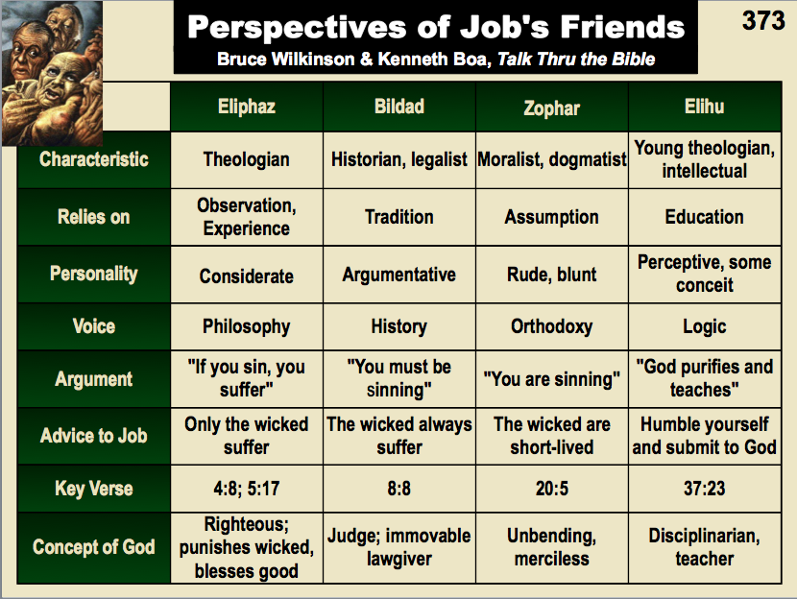

These principles in understanding the book of Proverbs can help:

The nature of this literary type (genre) requires greater discernment in interpretation. Most of the problems stem from the frequent quotation of a proverb as an absolute promise or principle that has no exceptions. For example, consider the proverb about child rearing:

“Train a child in the way he should go, and when he is old he will not turn from it” (Proverbs 22:6)

This has often been taken to be an unconditional promise. The problem comes when godly parents who raise a child in a godly manner find that the child later rejects these values. Questions like “Did they really do a good job in raising the child” and “How can they say they raised the child properly?” arise based upon this verse.

In response, these hermeneutical guidelines may help to interpret Proverbs properly:

Do not consider the proverbs as promises from God but rather as general observations and principles that are usually valid but not always (cf. Zuck, A Biblical Theology of the OT, 234). Thus, in the case above, as a rule godly parents generally raise godly children, but exceptions occur–even biblical ones such as Samuel whose sons were dishonest (1 Sam. 8:1-5) and Hezekiah, one of the most godly Judean kings, whose son Manasseh was one of Judah’s most evil kings (2 Kings 21–22). Solomon also had a godly father, David, yet later was an idolater. Other proverbs also are not promises (e.g., 10:4; 12:11, 24).

Old Testament teaching must be understood in line with revelation given directly to the church (Acts and Epistles) in this dispensation. At least three types of statements would be applicable (from Homer Heater, DTS class notes, pp. 210-11):

Reiterated statements: These appear in the NT epistles in the same or similar form. “Thou shalt not bear false witness against your neighbor” (Exod. 20:16) is reiterated in “Stop lying to one another” (Eph. 4:25).

Quoted statements: When the NT quotes an OT passage to apply truth, it applies to the Church. “If your enemy hungers, feed him” (Prov. 25:21) reappears in Paul’s instructions (Rom. 12:20; cf. Matt. 5:44).

Parallel statements: While similar to the reiterated statements above, these are more general. Wise words which “keep you from the adulteress” (Prov. 7:24) find a parallel idea in the NT: “It is God’s will that you should be holy; that you should avoid sexual immorality” (1 Thess. 4:3).

Proverbs which find no repetition, quote, or parallel in the NT should not be treated as commands. However, if they are not contrary to NT teaching they may be applied as principles.

Tips for Interpreting the Psalms

Give attention to repeating refrains, phrases, or ideas to identify the structure so as to outline the psalm correctly. Note especially Hebrew parallelism.

Summarize the message of the psalm in a sentence.

Consider the historical notations in the text and/or title to discover the historical setting.

Classify the psalm using one of F. Duane Lindsey’s categories (OT Survey class notes on Psalms).

Take into account the progress of revelation so as to correctly interpret incomplete theology (e.g., 51:11, “…do not…take your Holy Spirit from me”).

Reword figures of speech to give their meaning.

Use New Testament allusions and/or quotations of the psalm for understanding, but do not read back into the text what the original author and audience would not have understood.

Contrasting Types of Old Testament Literature

Historical Books | Poetical Books | Prophetical Books
Past | Present | Future
What the people did | What the people felt | What the people should do
National | Individual | National & Individual
Actions | Axioms | Alarms
War history | Worship helps | Warning & hopes
Soldiers | Sages | Servants
Records | General revelation | Special revelation
Many ANE parallels | Many ANE parallels | Few ANE parallels
(ANE = Ancient Near East)

Interpreting the Prophets

Inaccurate Presuppositions: We tend to think that prophecy always concerns predictions about the future, which is actually only part of the story. Prophecies actually have the dual themes of repentance and judgment (Walk Thru uses the phrase “shape up or ship out”). These two elements appear in the following dual distinction of the two types of prophecies:

Ethical
Forthtelling
Mosaic Covenant

Predictive
Foretelling
Abrahamic Covenant

Ethical (forthtelling): The prophets relate to the present moral life of the hearers. All 17 prophetic books contain ethical teaching that demands repentance from the hearers. The foundation of their preaching was the Mosaic covenant. Often they referred to the blessings and cursings of obeying or disobeying the Law (cf. Lev. 26; Deut. 28).

Predictive (foretelling): The prophets also relate to the future eschatological events about the Messiah, Israel, Judah, and other nations (but never the Church, which is not mentioned in the OT; cf. Eph. 3:2-11). Here the reference is to the Abrahamic covenant. In broad terms the predictive prophecies can be categorized into two types:

Fulfilled

Concerning Israel, Judah, and other nations

Concerning Jesus' first advent

Unfulfilled

Concerning Israel, Judah, and other nations (mostly relating to the judgment preceding the kingdom and especially about the kingdom age itself)

Concerning Jesus' second advent

Hearer Orientation: The Hebrew word for “prophet” is related to the word for “mouth” since prophets spoke for God. This means the writings actually better served as sermons more than as literature (i.e., oral more than written). Thus, structural markers in the text itself should carry more weight than chapter and verse divisions that were added much later.

Non-Chronological Orientation: The longer books (major prophets) are essentially “collections of spoken oracles, not always presented in their original chronological sequence, often without hints as to where one oracle ends and another begins, and often without hints as to their historical setting. And most of the oracles were spoken in poetry!” (Fee and Stuart, 150-51).
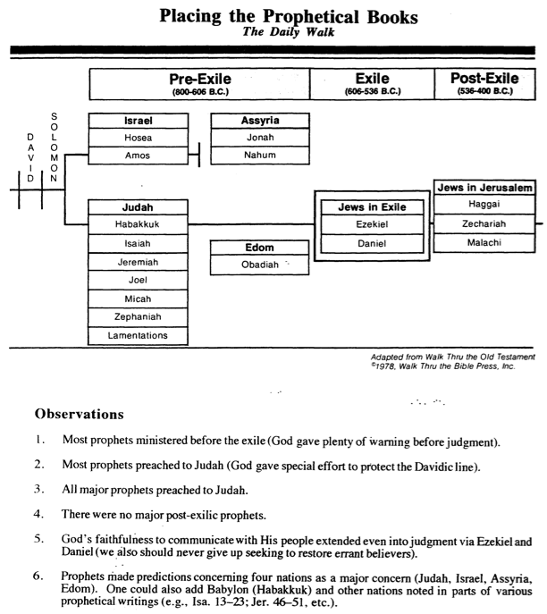

Incomplete Background Data: Prophets wrote to people familiar with the Law so alluded to events, practices, words, etc. without explanation:

Isaiah’s use of an exodus motif (cf. 4:5; 10:24-26; 11:16; 43:14-21; 48:20-21; 51:9-10)

Amos’ ironic use of traditions related to Israel’s election (3:2), the Day of the Lord (5:18-20), and the Passover (5:17)

The secular “suzerain-vassal” treaty relationship model (cf. Deuteronomy notes) finds a parallel in which God acts as the “Great King” (suzerain) towards His people (vassal) in line with the Mosaic Covenant (conditional covenant they made). In this relationship prophets serve as messengers of Yahweh, who have stood in His council and speak by His authority. They accuse Yahweh’s disobedient vassal of breach of covenant and threaten implementation of the covenant courses. Compare the accusations of the prophets with the OT law’s covenant stipulations (cf. Hos. 4:2 with Exod. 20:7, 13-16) and the covenant curses (cf. Isa. 1:7-8 with Deut. 28:33, 51-52; Isa. 1:9 with Deut. 28:62; 29:23).

The promise or salvation oracle of the prophets also pictures God’s restoration of His people after judgment. This is based on the covenant of “grant” made with Abraham and extended to David, foreseen even by Moses (Deut. 30:1-10). Prophets also anticipate the ultimate fulfillment of the Abrahamic promises (cf. Hos. 1:10) and the establishment of the Davidic throne (cf. Isa. 11). The common elements are three: reference to the future, mention of radical change, and mention of blessing (Amos 9:11-15; Hos. 2:16-22; 2:21-23; Isa. 45:1-7; Jer. 31:1-9; cf. Fee and Stuart, 160).

The covenant lawsuit (Isa. 3:13-26; Hos. 4:1-19, etc.) is still another form, depicting God “imaginatively as the plaintiff, prosecuting attorney, judge, and bailiff in a court case against the defendant, Israel” (ibid.).

The woe oracle (Mic. 2:1-5; Hab. 2:6-8; Zeph. 2:5-7) makes use of the common word “woe” which Israelites cried out when experiencing disaster, death, or funeral mourning. “Woe oracles contain, either explicitly or implicitly, three elements that uniquely characterize this form: an announcement of distress (the word “woe” for example), the reason for the distress, and a prediction of doom” (ibid., emphasis theirs).

Historical Distance: Even if we know the historical setting, it is still very different than we are used to today, so we should always be familiar with the date, audience, and circumstances of the prophetic passages we read. In general terms, the 16 prophets wrote in a relatively small time period of only four centuries between Obadiah (ca. 845 BC) to Malachi (ca. 425 BC) which was characterized by three factors (adapted from Fee and Stuart, 157):

Unprecedented upheaval in the political, military, economic, and social realms

Religious unfaithfulness on Israel’s part to the Mosaic covenant

Shifts in populations and national boundaries

Lack of Appreciation for Poetry: This also prevents us from understanding and appreciating the prophetical literature. For an introduction see the Psalms section of these notes.

Unfamiliarity of Prophetic Books: The fact that these books are rarely preached and taught also makes them difficult to interpret. They constitute 17 writings to six different audiences in three time periods with many geographical and situation changes. See the overview charts on the following pages to help clear up some of the confusion.

Ignorance of Eschatology: Most Christians are unable to state a biblical view of future things and therefore find it difficult to fit the prophetical eschatology into a larger framework. To understand these writings fully one must know something about the biblical covenants (see Genesis notes) and eschatological events in succession (see Daniel notes).
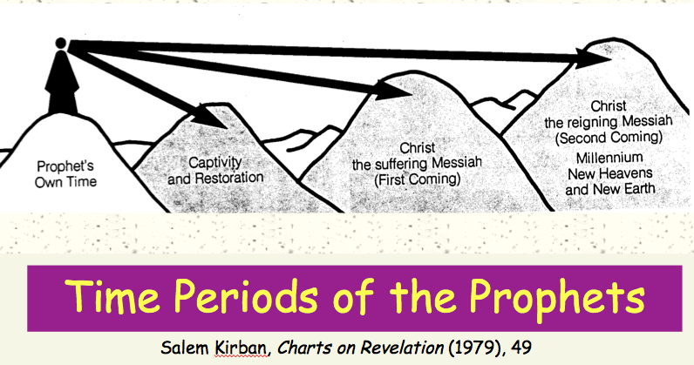

H. Dual Eschatological Viewpoint: The preceding point addressed the fault of the readers but this one refers to the fact that the prophets themselves often blur chronological distinctions. They often depict as a single event two or more events that we now know to be separate. In this scheme the fulfillment of the nearer event serves as a “down payment” that the entire vision will be eventually fulfilled. This has been diagrammed clearly as two perspectives on two disks, a smaller one in front of a larger from a front view, but “then from the perspective of subsequent history to see them from a side view and thus see how much distance there is between them” (Fee and Stuart, 164):

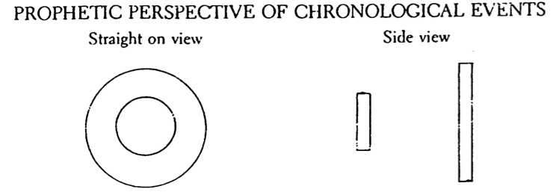

The Purpose of the Prophetical Books

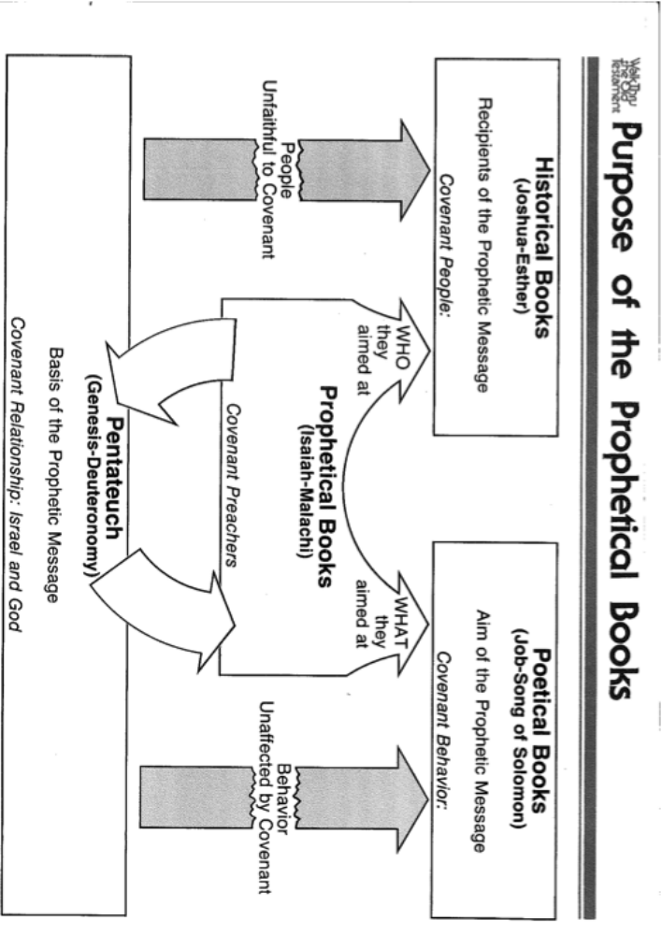

Interpreting the Gospels & Acts

Many of the tips for interpreting OT narratives (historical books) would apply here too. The Gospels and Acts are stories with a theological purpose. However, the other points below show some differences.

Gospels are not biographies of Jesus Christ. Instead of recording everything from birth to death as a biography does, each records only those events that contribute to the author’s unique purpose.

Each gospel should stand on its own since each presents a unique view of the life of Christ. In other words, do not think that the same story in each gospel must communicate the same truth as the other gospels.

Although Jesus came to bring in the new covenant, he did not do this until the night before his death. Therefore, the gospels record life under the law—or a transitional period between the old covenant and the new. Jesus was “born under the Law” (Gal. 4:4).

Parables present a unique challenge for interpretation.

Parables should not be “spiritualized” as allegories but rather taken in their normal sense. The fourth-century scholar Augustine offers the following interpretation of the parable of the Good Samaritan:
- The travelling man = Adam
- Jerusalem = the heavenly city of peace from which Adam fell
- Jericho = the moon, representing Adam’s mortality
- Thieves = the devil and his angels
- Stripped him = robbed him of his immortality
- Beat him = by persuading him to sin
- Left him half-dead = half-dead because he is alive physically but dead spiritually
- Priest and Levite = the priesthood and ministry of the Old Testament
- Samaritan = Christ (he says the word means “Guardian”)
- Bound his wounds = binding the restraint of sin
- Oil = comfort of good hope
- Wine = exhortation to work with a fervent spirit
- Beast = the body of Christ’s incarnation
- Inn = the church
- Tomorrow = after the Resurrection
- Two-pence = promise of this life and the life to come
- Innkeeper = Paul

Ask the meaning of the key point of the story rather than assuming each detail has an application.

Though we all can learn from each parable, note that not every parable is directly for every person. Jesus spoke different ones to different people, so pay attention to which person(s) he directed each story.

Parables teach about the kingdom of God—the rule of God on extended on earth during the time of Jesus (thus “already” here now) but not fully seen until the second coming of Christ (the “yet” future). Theologians thus call the kingdom “already/not yet.”

Parables expect a response. Jesus did not give them simply to entertain or to satisfy our curiosity.

One of the reasons Jesus taught in parables was to challenge people to think about the meaning of the story. Some people may have come to Jesus expecting to hear meaty theological sermons and would go away baffled and disappointed by the simple stories he told. No one could understand the parables unless they dedicated themselves to making the connection between the point of the story and their own lives. In this sense the parables are much more than just illustrations of a point – they are intended both to filter out those who were not serious about listening and are also a way to bring God’s truth to life in the hearts of those who heard and understood. Jesus made this purpose clear when he said that “to those on the outside everything is spoken in parables so that, ‘they may be ever seeing but never perceiving, and ever hearing but never understanding, otherwise they might turn and be forgiven’” (Mark 4:11-12; also Matthew 13:10-15; Luke 8:9-10). These verses should not be understood as the only purpose for which Jesus used parables, as in other cases it is clear from the context that He used them to illustrate teaching for His disciples (e.g. Luke 7:40-43 or Matthew 24:32-25:46) or to challenge people in the crowd and even His opponents to respond (e.g. Luke 10 or Luke 15).

Interpreting the Epistles

Give careful attention to the situation of the recipients: The letters of Paul all address specific churches (e.g., Rome, Corinth, etc.) or individuals (e.g., Timothy, Titus, Philemon). However, other letters, called General Epistles, are written to specific individuals (2-3 John) or groups (1-2 Peter, Hebrews) or address Christians in general (James, 1 John).

The admonition to “remain in the [marital] state you are in” (1 Cor. 7:17, 20) should be taken in light of the “present crisis” affecting the Corinthian church (1 Cor. 7:26).

The recipients of the letter to the Hebrews were in danger of abandoning their faith by returning to Judaism. Thus the warnings to them in chapters 6 and 10 are not simply “small sins” characteristic of all believers.

The most difficult times in the first century were the 60s and 90s. Note on the chart below the many letters written during these years of persecution by Nero and Domitian, respectively. Jude and 1-3 John were probably composed from AD 75-85 while John Revelation around AD 95, but 13 of the 27 NT letters stem from the 60s! Read these letters as you would letters to people undergoing severe trial.

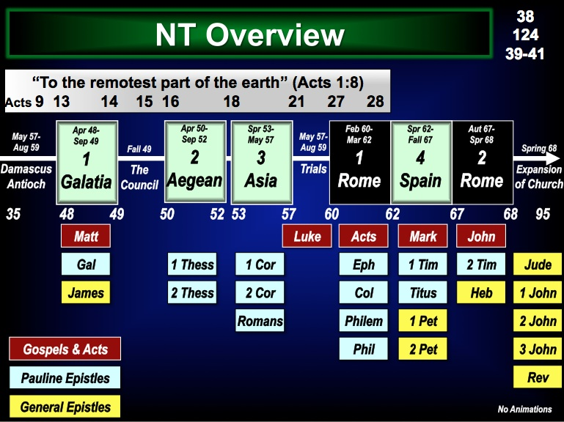

All epistle commands are not commands for us: Exercise cultural sensitivity. Paul required not only Corinth, but also the other churches to have their women wear head coverings (1 Cor. 11:16). But is this for us today? It certainly would apply in South Asia (India, Pakistan, Bangladesh, Nepal, etc.) where the head covering denotes submission. But must it apply elsewhere where such coverings have nothing to do with a wife being subject to her husband? Wouldn't this principle better apply to women who refuse to quit their jobs to stay at home when their husbands insist upon it?

Do not read your own culture into the text: Here is a related problem to that above. Paul said that nature itself teaches that men should not have long hair while women should (1 Cor. 11:14-15). However, many cultures do not obey this verse because long hair for men and short hair for women appears stylish.

A text cannot mean what it never could have meant to its author or his readers. Exegesis must come first. For example, could the recipients of Hebrews 6 and 10 have lost their salvation? Was it possible for them to lose eternal life if it actually was eternal? If they could not, then we cannot.

Give priority to the author’s own use of words: For example, don’t assume that Paul meant the same thing by “justified” (Rom. 3:20) as James did with the same word (James 2:24). Paul was referring to non-Christians while James had a Christian audience in view. It is best to interpret Paul with his own use of words and to do the same with James.

Interpreting Revelation

Now we come to the most difficult of the books of the Bible to interpret. Why? The Apocalypse (“revelation, unveiling”) uses many strange symbols and assumes that we know the other 65 books of Scripture, to which it constantly alludes. In this vein, keep these four basic interpretive rules in mind:

Follow the normal sense unless it’s nonsense.

144,000 witnesses of Israel (7:4)

1000 years of saint’s reign (20:4)

1260 days of prophesying (11:3)

3½ days of death (11:9)

Euphrates dries up (16:12)

Weights (16:21) and lengths (21:16)

The number 7 points to completeness but also should be taken at face value.

The number 7 in the rest of the Bible (representative examples):


Creation (Gen. 2:2)

Rain (Gen. 7:4)

Sabbath (Exod. 20:10)

Jericho (Josh. 6:4)

Sons (Job 1:2; Ruth 4:15)

Prophecy (Dan. 9:24)

Forgive (Matt. 18:21)

The number 7 appears 55 times in Revelation (some examples):

Churches 1:4a

Spirits 1:4b

Lampstands 1:12

Stars 1:16

Seals 5:1

Eyes 5:6

Angels 8:2

Trumpets 8:2

Peals 10:3

7000 killed 11:13

Heads 12:3a

Diadems 12:3b

Plagues 15:1

Bowls 15:7

Mountains 17:9

Kings 17:10

“It is worth noting that there are seven “beatitudes” in Revelation: 1:3; 14:13; 16:15; 19:9; 20:6; 22:7, 14.

Revelation 11:1-12 is a “Test Case in Hermeneutics” that shows the reasonableness of taking the text in its normal sense (see the comparative study on the next two pages).

Three Views on Revelation 11
Based on a handout presented by Robert L. Thomas at the Evangelical Theological Society meetings in Boston, November 1999

Various hermeneutical approaches to the witnesses of Revelation 11 yield widely different evangelical interpretations. The following quotes and their page numbers come from Gregory K. Beale, The Book of Revelation: A Commentary on the Greek Text, New International Greek Testament Commentary (Grand Rapids: Eerdmans, and Carlisle, UK: Paternoster, 1999); ETS paper by Grant Osborne, 1999 (author of The Hermeneutical Spiral); and Robert L. Thomas, Revelation: An Exegetical Commentary, 2 vols. (Chicago: Moody, 1992, 1995).

Revelation 11:1-3 (NIV)
¹I was given a reed like a measuring rod and was told, "Go and measure the temple of God and the altar, and count the worshipers there. ²But exclude the outer court; do not measure it, because it has been given to the Gentiles. They will trample on the holy city for 42 months. ³And I will give power to my two witnesses, and they will prophesy for 1,260 days, clothed in sackcloth."

Term or Expression | Beale  Symbolic |  | Osborne  Symbolic-Literal | Thomas  Literal
1  “measure”  (11:1) | “the infallible promise of God’s future presence”; “the protection of God’s eschatological community” (559); “until the parousia” (566) |  | “preservation of the saints spiritually in the coming great persecution” (5; cf. 7); “a prophetic anticipation of the final victory of the church” (8) | “a mark of God’s favor” (80-81)
2  “the temple (naon)”  (11:1) | “the temple of the church” (561); “Christians” (562); “the whole covenant community” (562); “the community of believers undergoing persecution yet protected by God” (566) |  | The heavenly temple depicting “the church, primarily the saints of this final period but secondarily the church of all ages” (6; cf. 7 n. 4) | “a future temple in Jerusalem during the period just before Christ returns” (81-82)
3  “the altar”  (11:1) | “the suffering covenant community” (563) |  | the [heavenly] altar of incense” (6) | “the brazen altar of sacrifice in the court outside the sanctuary” (82)
4  “the worshipers”  (11:1) | “believers worshiping together in the temple community” (564) |  | “individual believers” (7) | “a future godly remnant in Israel” (82)
5  “in it” (11:1) | in the temple or the altar (571) |  | “in the church” or “at the altar” (7) | “in the rebuilt temple” (82)
6  “the court that is outside the temple (naou)” (11:2) | “God’s true people,” including Gentiles (560) |  | “the saints who are persecuted” (8) | “the wicked without God” (83)
7  “cast outside” or "given to" (NIV)  (11:2) | “not protected from various forms of earthly harm (physical, economic, social, etc.)” (569) |  | not protected from Gentiles/nations (8); God delivers his followers into the hands of sinners (9) | “exclusion from God’s favor” (83)
8  “the Gentiles” (11:2) | “the Gentiles and Jews” (569) |  | “the church handed over to the Gentiles/nations for a time” (9) | “a group [of non-Jews] in rebellion against God who will oppress the Jewish remnant” (83-84)
9  “they will trample on” (11:2) | persecution of the church from Christ’s resurrection until His first coming (567) |  | “the saints will suffer incredibly” in a physical sense (10) | “future defilement and domination of Jerusalem” (86)
10  “the holy city” (11:2) | “the initial form of the heavenly city, part of which is identified with believers living on earth” (568) |  | “the people of God” (9) | “the literal city of Jerusalem on earth” (84)
11  “forty-two months”  (11:2) |  | “figurative for the eschatological period of tribulation” (565); “attack on the community of faith throughout the church age” (566) | “the ‘great tribulation’ at the end of history” (1, 12) |  | “the last half of Daniel’s seventieth week” (85)
12  “the two witnesses”  (11:3) |  | the church; “the whole community of faith” (573) | “two major eschatological figures… as a symbol for the witnessing church” (14, 16) |  | two future prophets, probably Moses and Elijah (87-89)
13  “the great city” (11:8) |  | “Babylon” = “Rome” = “the ungodly world” (591-592) | Jerusalem and Rome’ secondarily, all cities that oppose God (27) |  | Jerusalem (93-94)
14  the resurrection and ascension of the two witnesses (11:11-12) |  | “divine legitimization of a prophetic call” (599) | “A proleptic anticipation of the ‘rapture’ of the church” (35) |  | the resurrection of the two witnesses (97)

Summaries (this strings the above descriptions into interpretive sentences of 11:1-3, 8, 11-12)

Beale (Symbolic)
¹I was given a reed symbolizing the infallible promise of God’s future presence and was told, “Go and protect God’s eschatological community (which is the temple of the church) until the parousia and protect the suffering covenant community and count the believers worshiping together in the temple community. ²But exclude God’s true people, including Gentiles; do not protect this suffering covenant community of Gentiles and Jews because they are not protected from various forms of earthly harm (physical, economic, social, etc.). They will attack and persecute the whole community of faith throughout the church age which is the initial form of the heavenly city, part of which is identified with believers living on earth for the eschatological period of tribulation. ³And I will give power to the church, and this whole community of faith will prophesy for the eschatological period of tribulation… [but after being killed] ⁸their bodies will lie in the street of Babylon or Rome which means the ungodly world [then they will receive] ¹¹⁻¹²divine legitimization of a prophetic call.

Osborne (Symbolic-Literal)

¹I was given a reed like a measuring rod and was told, “Go and preserve the saints spiritually in the coming great persecution (but secondarily the church of all ages) in anticipation of their final victory and measure (preserve?) the [heavenly] altar of incense, and count the individual believers in the church or at the altar. ²But exclude the saints who are persecuted… because they have not been protected from Gentiles/nations as God delivers his followers into the hands of sinners for a time. The saints will suffer incredibly in a physical sense in the people of God for the ‘great tribulation’ at the end of history. ³And I will give power to my witnessing church, and they will prophesy for 1,260 days, clothed in sackcloth… [but after being killed] ⁸their bodies will lie in the street of Jerusalem and Rome which secondarily refer to all cities that oppose God [then they will receive] ¹¹⁻¹²a proleptic anticipation of the ‘rapture’ of the church.

Thomas (Literal)

¹I was given a reed like a measuring rod and was told, “Go and measure as a mark of God’s favor the future temple in Jerusalem during the period just before Christ returns and the brazen altar of sacrifice in the court outside the sanctuary, and count the future godly remnant in Israel in the rebuilt temple. ²But do not measure as a mark of God's favor the wicked without God… because they have been excluded from God’s favor [and are] a group [of non-Jews] in rebellion against God who will oppress the Jewish remnant. They will trample on Jerusalem for the last half of Daniel’s seventieth week. ³And I will give power to my two future prophets (probably Moses and Elijah), and they will prophesy for 1,260 days, clothed in sackcloth… [but after being killed] ⁸their bodies will lie in the street of Jerusalem [then three and a half days later will] ¹¹⁻¹²be resurrected.
Continuing point “O” on Four Interpretive Principles to Understand Revelation…

Be consistent with Daniel's parallel prophecy.

Ten-horned Beast (Dan. 7:7-8): This denotes a world ruler aligned with Rome that John saw as still future (Rev. 17:3, 10-11).

7-year covenant (Dan. 9:27): Daniel’s teaching that halfway through this period a world ruler will desecrate the temple (cf. Rev. 13:14). Jesus also saw this as future from his time (Matt. 24:15).

1290-day trial (Dan. 12:11) correlates closely with the 1260-day trial of John’s vision (Rev. 11:3; 12:6).

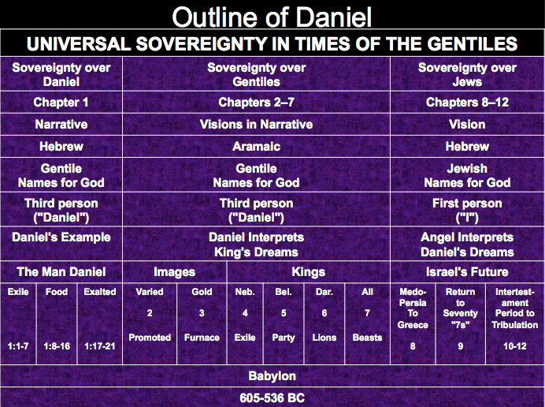

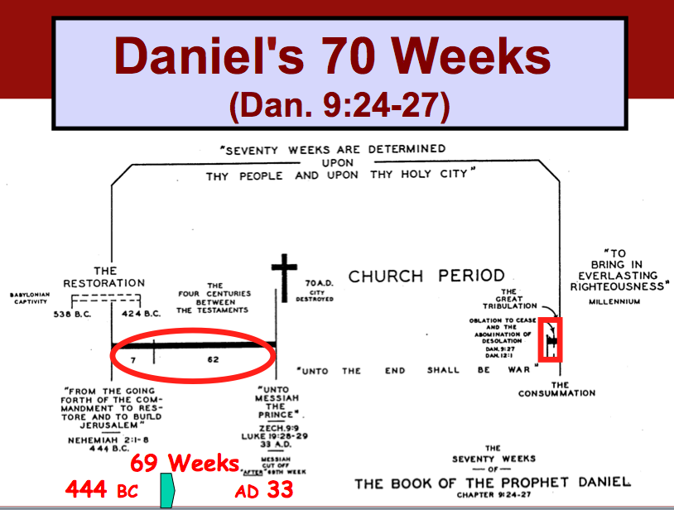
Daniel’s 70 Weeks

R. Ludwigson, A Survey of Bible Prophecy (Grand Rapids: Zondervan, 1975), 49

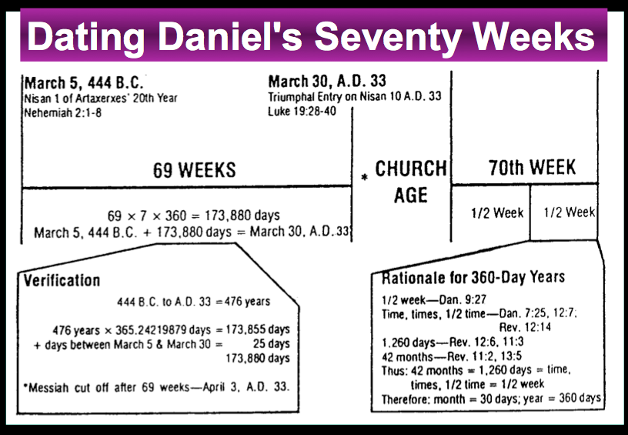
Harold W. Hoehner, Chronological Aspects of the Life of Christ (Grand Rapids: Zondervan, 1977), 139
Chronology of the Seventieth Week
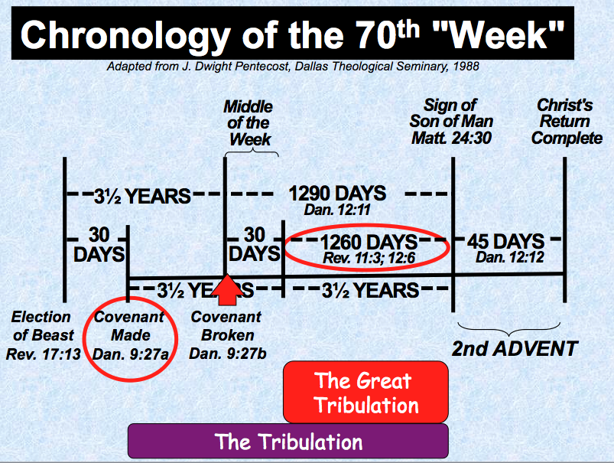

Continuing point “O” on Four Interpretive Principles to Understand Revelation…

Assume a chronological order.

The normal way to read a book is to assume, unless otherwise indicated, that the story proceeds from point A to point B in time. There is no reason not to follow this normally accepted practice when reading the Revelation to John.

However, the recapitulation approach has recently gained some following where the book is seen as depicting the present church age seven different times.

According to this view, chapters 1–3 cover the same time period as chapters 4–7 as both supposedly cover the time period between Christ’s first and second comings.

Five more sections follow to depict the same church period.

This view is diagrammed on the next page.

A Recapitulation Approach to Revelation
William Hendriksen, More Than Conquerors, 16-19

One common view of the book of Revelation by amillennial scholars sees it as presenting our present age seven times in parallel sections. Hendriksen is typical of this view which spiritualizes the 1000 years of Revelation 20:1-6 and applies this time period to our own Church Age. (Other commentators who see it this way are Lenski, Warfield, Sadlet, and S. L. Morris; cf. John Gilmore, Probing Heaven). In chart form the view would look like this:
Second Coming

Millennium = Christ reigning with His saints in heaven during the Church Age
Eternity

Premillennial Response

Christ in the Midst of the Seven Lampstands (1–3)  Seven literal churches of Asia each depict conditions in congregations  throughout the church age until Christ’s return (1:7) | Correct except that 1:19 denotes the vision of Christ (1:9-18) as past, with 1:7 looking to his final triumph
The Vision of Heaven and the Seven Seals (4–7)  Christ rules from heaven now (5:5-6) until the second coming (6:16-17)  at the end of the age with the triumphant church (7:16-17) | Rev. 5:5-6 and 6:16-17 do not say this, the seals have not yet happened, and 7:16-17 is about tribulation believers
The Seven Trumpets (8–11)  A series of repeated judgments in the present age afflicts the wicked (8–9)  but the Church is protected (10–11) until the final judgment (11:15, 18) | Trumpets occur after the seals and in sequence; even a casual observation shows they have not yet occurred (e.g., 8:8-12)
The Persecuting Dragon (12–14)  A woman (the Church) gives birth to a child (Christ) but she is persecuted by the dragon (Satan) and his agents until the second coming (14:14, 16) | The woman is Israel that gave the Messiah and Jews will be persecuted 3 and 1/2 years (12:6)
The Seven Bowls (15–16)  The disappearance of islands and mountains (16:20) is the final judgment and  chapters 15–16 are “events that will take place in connection with it” | Agreed, so these chapters do not denote the whole church age as Hendriksen claimed of each section
The Fall of Babylon (17–19)  Babylon (the world system of seduction) continues during the entire church age  until its destruction at Christ’s second coming (19:11-21) | This chronological parenthesis in the book shows how this entity in the end times will be destroyed
The Great Consummation (20–22)  The present age (20:1-6) is not a literal 1000 years and this “millennium” occurs before chapter 19 and is followed by a general judgment and the eternal state | It is more natural for Christ’s return (Rev. 19) to precede his rule (Rev. 20) over a literal 1000 year period

Problems with the Recapitulation View

See rebuttals to the right of the Recapitulation diagram above.

Does Christ’s return really appear repeatedly in the book? Even if it does (e.g., 1:7), These verses all look forward to Christ’s ultimate return in chapter 19.

Beale defends the view this way: "The strongest argument for the recapitulation view is the observation of repeated combined scenes of consummative judgment and salvation found in various sections throughout the book."

Some responses to a few supposed examples of recapitulation:

The Text: The sixth seal is very early in the cycles of judgment yet states amazingly, “I watched as the Lamb broke the sixth seal, and there was a great earthquake. The sun became as dark as black cloth, and the moon became as red as blood. ¹³Then the stars of the sky fell to the earth like green figs falling from a tree shaken by a strong wind. ¹⁴The sky was rolled up like a scroll, and all of the mountains and islands were moved from their places” (6:12-14 NLT).

The sky was split apart like a scroll when it is rolled up (6:14 NAU)

Recapitulation Claim: Beale, 398, notes that 6:12-14 has two descriptions of the sixth seal that correspond to the seventh bowl at the end of the tribulation in 16:17-21:

The great earthquake (6:12a) also happens in 16:18 (probably also in 11:13).

Islands and mountains being removed (6:14b) also occur in 16:20. How could this happen twice?

Responses: Similar events do not indicate identical events.

Earthquake: This is a huge earthquake never seen on the earth up to that point (6:12a), but it need not indicate Christ’s return. In fact, the earthquake of 16:18 is greater since “no earthquake like it has ever happened since man was on earth…”

Stars: Must 6:13 be the end of the world? It may sound like it, if the verses refer to all the stars and to the entire sky. But the text must not be forced to read all of the stars. “The phenomenon is so large that it appears from man’s perspective that the stars are falling, when in reality it is probably a very large meteor shower that invades the terrestrial atmosphere (Hailey)” (Thomas, 1:454).

But Stephen, full of the Holy Spirit, gazed steadily into heaven and saw the glory of God, and he saw Jesus standing in the place of honor at God’s right hand. ⁵⁶And he told them, “Look, I see the heavens opened and the Son of Man standing in the place of honor at God’s right hand!” (Acts 7:55-56 NIV)

Sky: God will peal back the sky like scrolls on either side, but this will not signal the end of the world. He has done this at times in the past as well (e.g., Acts 7:55-56), but “the old heaven” or sky will not be replaced until later when God creates “a new heaven” (21:1). The sky still exists even in 16:21 since it emits hail.

Islands and mountains disappear, but not entirely. That the sixth seal earthquake is not literal but exaggerated is supported by the following verses that show men calling on the mountains to fall on them (6:16). Obviously, some mountains still exist in chapter 6. In contrast, following the larger earthquake of 16:18, “every island fled away and the mountains could not be found.” The seventh bowl in Revelation 16:17 is the last chronological event prior to the return of Christ since Rev. 17–18 are parenthetical.
Continuing point “c” on Problems with the Recapitulation View…

Judgments increasingly progress and intensify throughout Revelation.

Seal judgments are not as severe as trumpet judgments, which in turn fail in intensity to the bowl judgments at the return of Christ.



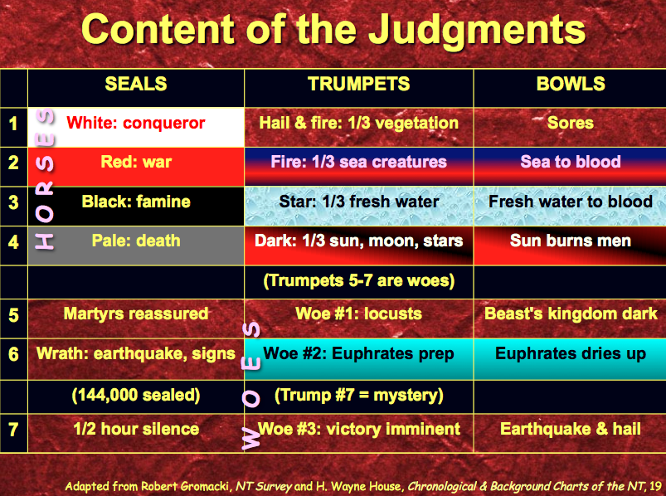

Satan’s judgment is also progressive, from being expelled from heaven (2:8-9) to being locked in the Abyss for 1000 years (20:1) to finally being thrown into the lake of fire (20:10).
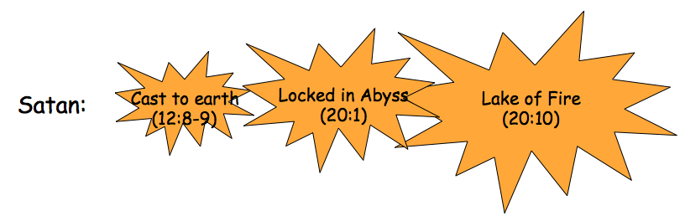

Continuing point “O” on Four Interpretive Principles to Understand Revelation…

Use Revelation’s inspired outline in 1:19.

Some deny this to be a chronological marker, such as Beale, 216:

“Among the numerous interpretations of this notoriously difficult threefold clause, the following six appear to be most plausible:

(1) John is to write down the entire vision (v 19a), in particular that of chs. 1–3 (v 19b) and those of chs. 4ff., which follow historically after those of chs. 1–3 (v 19c).

(2) John is to write down the vision in 1:12–18 (v 19a), as well as that of chs. 2–3 (v 19b), and those visions of chs. 4ff. that come in order after those of chs. 1–3 (v 19c).

(3) John is to write down the entire vision that he saw (v 19a), which concerns realities pertaining to the present (v 19b) and the future (v 19c).

(4) In line with the threefold clauses of 1:4 and 1:8, the threefold clause of v 19 expresses not only eternal duration, but a revelation which transcends historical time and uncovers the meaning of existence and of history in its totality.

(5) John is to write down the entire vision that he saw (v 19a) pertaining to present realities (v 19b), which are to be understood as the beginning of the latter days and which will be concluded by the end of history (v 19c).

(6) John is commanded to write a book containing a threefold literary genre, which is visionary-apocalyptic (v 19a), figurative (v 19b, rendered as “what they mean”), and eschatological (v 19c, viewed in an already-and-not-yet sense). Among these six alternatives, the last three are preferable.

The least plausible view is that which understands the verse as a sequential chronological outline of the entire book, v 19a as pertaining only to the time of the vision in 1:12–18, v 19b pertaining only to the church age described in chs. 2–3, and v 19c pertaining only to the future tribulation period directly preceding and including Christ’s final coming (portrayed in chs. 4–21).

The meaning of v 19 is crucial since it is usually understood to be paradigmatic for the structure and the content of the whole book. For thorough discussion of the exegesis, alternative views, and interpretative problems of this verse see further pp. 152–70 above.”

Beale continues to argue that affinities between Daniel 2 and Revelation 1 argue that the two relate to the present age.

What can be said in response to this claim that Revelation 4–22 does not refer to the future but to the present?

One wonders if Beale himself considers all of Revelation 4–22 as signifying the present age. Certainly he would agree that the final two chapters relate to eternity, so he is inconsistent by claiming that this large section refers both to the present (Rev. 4–20) and the future (Rev. 21–22).

The inconsistencies of the recapitulation view have already been discussed.

The seal, trumpet, and bowl judgments contain such incredible descriptions that they cannot be true of the present age without spiritualizing them.

When in the present age have we seen one fourth of the world die by sword, famine or plague (6:8)?

When has an army of 200,000,000 crossed the Euphrates River for battle (9:16; 16:12-14)?

When has man witnessed 75-pound hail (16:21)?

Many other examples can be cited.

Argument

The Gospel writers give only a limited picture of Jesus Christ as they depict His deity, life, authority, death, and resurrection almost entirely in veiled form (cf. Phil. 2:5-8). The book of Revelation removes this veil and clearly shows Christ’s sovereignty in His future final triumph as King of Kings and Lord of Lords (17:14; 19:16). John records this triumph to encourage believers undergoing external opposition (Roman persecution) and internal compromise (deterioration within the churches) to give them hope.

As already mentioned, Revelation 1:19 provides an inspired outline of the entire prophecy. This begins with John's past vision of Christ's sovereignty (1:9-20), continues with a present description of Christ's sovereign authority over the seven churches (Rev. 2–3), and concentrates the bulk of the prophecy upon the future triumph of Christ over Satan and evil (Rev. 4–22).

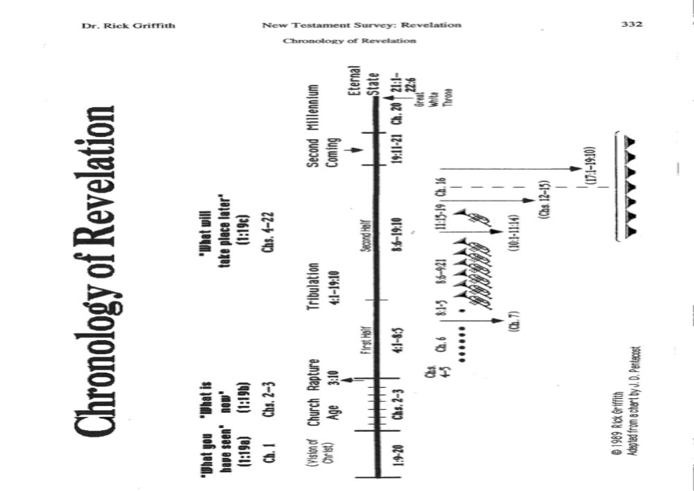
Chronology of Revelation

Adapted from Gordon Fee and Douglas Stuart, How to Read the Bible for All Its Worth, 136-39; these issues are addressed in detail in my ThD dissertation in the SBC library under Richard James Griffith, “The Eschatological Significance of the Sabbath,” Dallas Seminary, 1990, esp. pp. 144-56.
Adapted from J. Dwight Pentecost, Bibliotheca Sacra 128 (July 1971): 227-33.
Note that these principles also apply to stories within the Pentateuch and other OT historical narratives such as those in the Wisdom Literature (Job 1–2, 42) and Prophets (e.g., Isa. 36–39; Daniel 1, 6, etc.)
Adapted from Homer Heater, Dallas Theological Seminary, 1987 (unpublished class notes).
Adapted from Fee & Stuart, pp. 149f.
cf. Robert B. Chisholm, Jr., “Interpreting Prophetic Literature,” class handout, Dallas Seminary, 1-2.
See the article by J. F. Ross, “The Prophet as Yahweh’s Messenger,” in Israel’s Prophetic Heritage, ed. B. W. Anderson and W. Harrelson (London: SCM, 1962), 98-107.
Noted by Fee and Stuart, 1st ed., 124.
Paul B Coulter, “The Parables of Jesus” 2d ed. (January 2011), 3 (unpublished paper at www.paulcoulter.net/Teaching/Parables.pdf accessed 24 Jan 2013).
Another helpful point by Fee and Stuart, 1st ed., 60.
Warren W. Wiersbe, Revelation, The Bible Exposition Commentary (Wheaton, Ill.: Victor Books, 1996, c1989), 5 (online edition).
G. K. Beale, The Book of Revelation, GIGTC (Grand Rapids: Eerdmans, 1999), 121, emphasis mine.
Robert L. Thomas, Revelation 1–7: An Exegetical Commentary (Chicago: Moody, 1992), 455.

